CONTACT: Nancy Richards – 917-873-6389 (cell) /nancy@northcoastrep.org
MEDIA PAGE: www.northcoastrep.org/press
FOR IMMEDIATE RELEASE, PLEASE:

NORTH COAST REPERTORY SHINES SPOTLIGHT ON
HILARIOUS, HEART-TUGGING COMEDY,
INTO THE BREECHES!
By George Brant
A San Diego Premiere
Performances Beginning Wednesday, October 19, 2022
Running Through Sunday, November 13, 2022
Directed by Diana Van Fossen

Solana Beach, Calif. - That time-honored adage, “The Show Must Go On,” takes on new meaning in this endearing and moving comedy. INTO THE BREECHES! transports audiences to a small American playhouse in 1942. With the actors and director off at war, a group of passionate women face the daunting challenge of preserving the theatre’s reputation for mounting outstanding Shakespearean productions. Crammed with laughs and an abundance of visual humor, their fierce determination and unbridled enthusiasm will have audiences cheering as they prove that art and community triumph even in times of peril. Reserve your seats now for this powerful, witty play that captures the true meaning of being an American.

Diana Van Fossen directs Geno Carr,* Rosemarie Chandler, Taylor Henderson, Melanie Lora,* Mikaela Macias, Katie MacNichol,* James Newcomb,* and Shana Wride*. The design team includes Marty Burnett (Resident Scenic Designer), Matthew Novotny (Light Design), Renetta Lloyd & Roz Lehman (Costume Design), Ryan Ford (Sound Design), Cindy Rumley (Prop Design) and Peter Herman (Hair & Wigs) . Christopher Williams* is the Stage Manager.
*The actor or stage manager appears through the courtesy of Actors’ Equity Association. For photos, go to www.northcoastrep.org/press.

INTO THE BREECHES! previews begin Wednesday, October 19. Opening Night on Saturday, October 22, at 8pm. There will be special talkback on Friday, October 28, with the cast and artistic director. It will play Wednesdays at 7pm, Thursdays through Saturdays at 8pm, Saturday and Sunday matinees at 2pm with Sundays at 7pm through Nov.13th. (See Schedule below). North Coast Repertory Theatre is located at 987 Lomas Santa Fe Drive, Solana Beach, CA 92075. Tickets: Previews - $54 (including Friday preview at 2pm), Week Nights/Wed. & Sat. Matinees - $60; Sat. Eve. & Sun. Mat. $65; Sun Night - $57. Seniors, Students, Military & Educators - $3 off admission. Call 858-481-1055, or visit www.northcoastrep.org to purchase tickets.
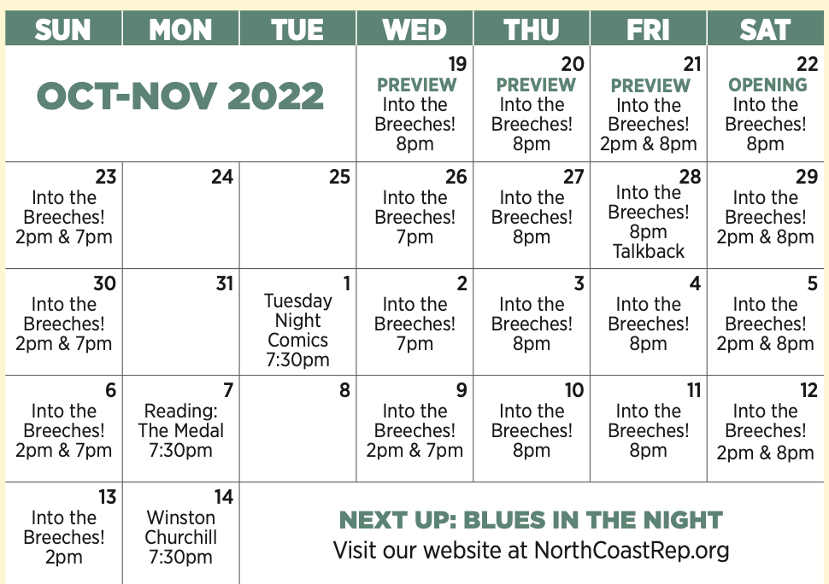

FACT SHEET:

WHAT: NORTH COAST REPERTORY THEATRE presents
INTO THE BREECHES!
A San Diego Premiere by George Brant
Directed by Diana Van Fossen

CAST: Geno Carr,* Rosemarie Chandler, Taylor Henderson, Melanie Lora,* Mikaela Macias, Katie MacNichol,* James Newcomb,* and Shana Wride*.

WHERE: North Coast Repertory Theatre
987 Lomas Santa Fe Drive
Solana Beach, CA 92075

SCHEDULE: Previews start October 19, 2022
Opens: October 22, 2022
Closes: November 13, 2022
Wed. @ 7pm, Thurs-Sat @ 8PM; Sat & Sun @ 2PM, Sun @ 7pm
Fri (Oct 21) @ 2pm
Wed (Nov 9) @ 2pm

PRICES: Previews $54.00
Week Nights & Sat. Matinees $60.00
Sat. Nights & Sunday Matinees $65.00
Sunday Nights $57.00

DISCOUNTS: Seniors, Students, Military & Educators $3.00 off admission. Rush tickets available for $20. Sold 15 minutes prior to showtime.

BIOS:

GEORGE BRANT (Playwright) plays include Grounded, Marie and Rosetta, Into the Breeches!, The Prince of Providence, Elephant’s Graveyard, Tender Age, The Mourners’ Bench, Any Other Name, Salvage and Grizzly Mama. An Affiliate Writer at the Playwrights’ Center, his scripts have been produced internationally by such companies as the Public Theater, the Atlantic Theater Company, Cleveland Play House, Trinity Repertory Company, the Studio Theatre, Alley Theatre, Asolo Repertory, London’s Gate Theatre, Page 73 and the Traverse Theatre. His plays have received a Lucille Lortel Award, an Edgerton Foundation New Play Award, the Smith Prize, a Fringe First Award, an Off-West End Theatre Award, an NNPN Rolling World Premiere, four OAC Individual Excellence Awards and the Keene Prize for Literature. George received his MFA in Writing from the Michener Center at UT-Austin and is a member of the Dramatists Guild.
DIANA VAN FOSSEN (Director) North Coast Rep debut. She has directed Midsummer Night’s Dream, A Christmas Carol, To Kill A Mockingbird, Merry Wives of Windsor, Much Ado About Nothing, Comedy of Errors, Romeo & Juliet, Henry VI, Wars of the Roses, Trojan Women and Deconstruction, No Mercy (Associate Artist, Alabama Shakespeare Festival) Angels In America (East Lansing), The Comedy of Errors (BoarsHead Theatre, Pulsar Award), Speak Truth To Power, Someone To Watch Over Me (Cranbrook), Much Ado About Nothing (Waterworks), Beyond Oz, Casualties (Heartlande), and Story Theatre (Interlochen). International Directors’ Symposium La Mama Umbria, Directors’ Lab West, LA, voice with Cis Berry and Patsy Rodenburg. MFA Bristol Old Vic Theatre School. Member of the Royal Shakespeare Company London’s West End in Piaf and Once In A Lifetime. Fight Director Certificate, Royal Society of Fight Directors. Two time Watson Fellow in experimental theatre. BA Goucher College. Acting career in film, BBC, National tours musicals, UK rep, car commercials, USA rep, and Off-Broadway, becoming the wife of an artistic director, a mother and theatre director along the way!!! First met David while in Winter’s Tale and Hamlet with his Father Robert at the Fort Worth Shakespeare Theatre. We go way back!!

(In order of appearance):
MELANIE LORA* (Maggie Dalton) was recently seen as Ruth in North Coast Rep’s The Homecoming earlier this year. A recent transplant to San Diego from LA, Melanie has worked extensively in Los Angeles theatre. LA/SoCal credits include The Hothouse (The Antaeus Company), Of Good Stock (world premiere), Elemeno Pea, Misalliance and Collected Stories (South Coast Rep), Dinner With Friends and Boeing Boeing (La Mirada Theatre), The Good Book of Pedantry and Wonder (Theatre@Boston Court), as well as productions at the Actors’ Gang, Ahmanson Theatre, Geffen Playhouse, Laguna Playhouse and many others. Film and Television: “Show Me Yours,” “Fish Head,” “I am I,” “The United States of Leland,” “Sons of Anarchy,” “Gilmore Girl,” and others. Lots of TV commercials and voiceover work as well, and most importantly, she is the mother to four spectacular children, ages 2-11. She is truly happy to be back at North Coast Rep and to be part of this wonderful show. melanielora.com @missmelanielora
KATIE MACNICHOL* (Celeste Fielding) North Coast Rep: Same Time Next Year, At This Evening’s Performance has appeared on Broadway in The Green Bird and Two Shake- spearean Actors and off Broadway in The Cider House Rules, King John and The Food Chain. In London she played the title role in A Chaste Maid in Cheapside at Shakespeare's Globe. As a member of The Old Globe Shakespeare Repertory Company she appeared in As You like It, Comedy of Errors, Macbeth, A Winter’s Tale (Craig Noel Award), The Merry Wives of Windsor, Twelfth Night, and others. Regional work includes: Fallen Angels at Pasadena and Laguna Playhouses, Good People at La Mirada and lead roles at Mark Taper Forum, Yale Repertory, Baltimore Center Stage, McCarter, Denver Center, Shakespeare Santa Cruz, Dallas Theater Company, Shakespeare Theatre of N.J., Westport Country Playhouse, Williamstown Theatre Festival and Portland Stage Company. Film and TV: “Law and Order: Criminal Intent”, “Medium”, “The Practice” and Spike Lee’s “Bamboozled”. BFA: N.Y.U. Tisch School of the Arts. MFA: Lesley University.
JAMES NEWCOMB* (Ellsworth Snow) The Old Globe: Twelfth Night, Coriolanus, and Much Ado About Nothing. San Diego Rep: Honky, Zoot Suit, Brooklyn Boy, and The Illusion. North Coast Rep: The Homecoming, Christmas Carol (as told by one man who cares - Streamed), How the Other Half Loves. Cygnet Theatre: Roy Cohn in Angels in America (Craig Noel award). Other Theatre: Oregon Shakespeare Festival (14 Seasons), Denver Center Theatre (9 Seasons), The Public Theatre, B.A.M. Utah Shakespeare Theatre, Shakespeare & Company (founding member),The Goodman, Chicago Shakespeare, Berkeley Rep. South Coast Rep, Portland Center Stage, Missouri Rep, Arizona Theatre Co., and Geva Theatre. Representative Roles: Oxford Society Award for Richard III (O.S.F.) Drama Log Award for Touchstone, (S.S.C.), Coriolanus, Iago, Bottom, Feste, and The Duke in Measure for Measure. T.V.: “The Hand That Rocks The Cradle,” “Honky” (P.B.S.), and “I Want To Keep My Baby” (CBS). Film: “Lone Wolf”. Directing: Much Ado, Midsummer (USD Graduate Program), Lone Star, True West, and Found a Peanut (National Theatre Conservatory). Continuing Lecturer : U.C.S.D. Graduate Theatre Program.
SHANA WRIDE* (Winifred Snow) is a theatre actor and director who has worked both locally and regionally with The Old Globe, The Shakespeare Center of Los Angeles, Diversionary Theatre, Cygnet Theatre, North Coast Repertory Theatre, Intrepid Theatre, Moxie Theatre, Compass Theatre, The Colony Theatre, Open Fist Theatre, San Diego Repertory Theatre, Idaho Shakespeare Festival, Gaslamp Quarter Theatre, and Sledgehammer Theatre. She is the recipient of a San Diego Critics Circle Craig Noel Award for her solo performance in 2.5 Minute Ride at Diversionary Theatre and for her performance as Amanda in Cygnet Theatre’s Private Lives. She holds a master’s degree in Theatre Arts from San Diego State University. While living in Los Angeles, she co-hosted the nationally syndicated radio show, “Women Aloud” with actor/comedienne Mo Gaffney.
GENO CARR* (Stuart Lasker) is thrilled to return to North Coast Rep, having appeared in Way Downriver, I Love You Because, A Christmas Carol, and several readings and galas. Geno originated the role of Oz & Others in the Tony Award-winning hit musical Come From Away on Broadway, also playing the role on the North American tour, at Ford’s Theatre in Washington, D.C., the Royal Alexandra Theatre in Toronto, and the world premiere at the La Jolla Playhouse. He has also appeared Off-Broadway, on five national tours, and in over one hundred plays and musicals across North America. San Diego credits include starring roles at The Old Globe, La Jolla Playhouse, Moonlight, Cygnet, Lamb’s Players, San Diego Musical Theatre, and Intrepid. Geno holds an MFA in Acting and Directing from Sarah Lawrence College and a dual BA in Music and Theatre from Hartwick College. Most important credit: husband to Nancy and father to Elliott. GenoCarr.com @GenoCarr

TAYLOR HENDERSON (Ida Green) is delighted to be back on the stages of NCRT and overjoyed to be performing again in San Diego after spending quarantine in her hometown of Las Vegas. Taylor has been performing and working professionally both on and offstage for over 10 years in various capacities as an actor, teaching artist, producer, director, and casting coordinator, as well as taking a new venture into immersive entertainment. During downtime, Taylor enjoys singing karaoke and playing Dungeons & Dragons. “Inspire, Aspire!” Selected credits:, All In The Timing, Twelfth Night and An Ideal Husband (North Coast Rep), As You Like It, Les Liaisons Dangereuses (New Fortune), Home Of The Brave, Under Construction (La Jolla Playhouse/Sledgehammer Theatre), Hairspray (SDMT), The Three-Penny Opera (UCSD), A Little Night Music, Avenue Q (Coronado Playhouse), RENT (Southwestern), “The Acey Deucey Club” (Fever US/Cinereal Productions), “Carnival Row” (Amazon Prime), “Fresh, Fried and Crispy” (Netflix), “Finding Magic Mike” (HBO Max) IG: @tay.renee.onstage

MIKAELA MACIAS (June Bennett) is grateful for her North Coast Repertory Theatre debut as June Bennet in Into the Breeches. Her previous roles include Performer in Pop-Up WoW Festival (La Jolla Playhouse), Noel in Noel, Noel (San Diego Symphony), Joan Arc in Mother of the Maid (Moxie Theatre), Dancer 1/ Woman 1 Understudy in Songs for a New World (Teatro San Diego), and Samantha Brown in The Mad Ones (Wildsong Productions). She is currently a 3rd-year Theatre Performance student enrolled at San Diego State University. Thank you to her mom, Tita, sister, and little cousin for being reminders of what powerful women can do.

ROSEMARIE CHANDLER (Grace Richards) is honored to be a part of this company and to be making her North Coast Repertory Theatre debut. Her favorite stories to share are ones of hope, so she is thrilled to be a part of Into the Breeches! Selected credits: The Hello Girls (Grace Banker), The Fantasticks (Luisa), The Drowsy Chaperone (Janet). Proud Northwestern University graduate. Love and gratitude to the Into The Breeches! cast, crew, and company, her family, friends, David Perlow, Barry Katz, and everyone and everything that provides encouragement and inspiration. www.rosiechandler.com

CHRISTOPHER WILLIAMS* (Stage Manager) is an actor, director, producer, fight director, stage manager and former Associate Artistic Director of North Coast Rep. Selected theatre credits: 29 mainstage shows at NCRT including Don’t Dress For Dinner, The Illusion, Gabriel, Dancing Lessons, and Desperate Measures; Rothschild & Sons (Original Off-Broadway cast); The Drawer Boy, A Moon For the Misbegotten (AZ Theatre Company); Angels In America I & II, Lobby Hero (Actors Theatre); Noises Off! (Idaho Shakespeare and Phoenix Theatre); Romeo & Juliet, Hamlet, Othello, Henry V (Southwest Shakespeare); Julius Caesar (New Village Arts); I Hate Hamlet (Intrepid Theatre); Biloxi Blues, Light Falling Down, The Elephant Man (Oceanside Theatre). He was also a producer of the WWII feature film, “Walking With The Enemy,” starring Sir Ben Kingsley and Jonas Armstrong.
DESIGN TEAM
MARTY BURNETT (Set Design) Resident Designer at North Coast Rep since 1992 and has designed more than 200 productions for the theater. Other design venues include: Sahara and Hacienda hotels in Las Vegas, Claridge Hotel, Atlantic City and Drury Lane Chicago.
MATTHEW NOVOTNY (Lighting Design) is pleased to be designing another show for North Coast Rep, where he has designed close to forty shows over the past seven years. Matthew is currently the Lighting Designer in Residence for San Diego Musical Theatre as well as North Coast Rep, and his work can be seen at a wide variety of theatres across San Diego. Matthew holds a B.A. in Technical Theatre from San Diego State and a master’s degree in Lighting Design from Boston University. Matthew is married to his beautiful wife Amanda, with 5 AMAZING children: Ragan, Harper, Heston, Maddex, and Harrison.
RENETTA LLOYD & ROZ LEHMAN (Costume Design) Renetta and her mother, Roslyn, are happy to be collaborating again on this fun show! Having been forced to slow down over the Pandemic years, it’s delightful to be back to theatre work. The pair have worked together for the last 25 years at North Coast Rep, Mira Costa College, Scripps Ranch Theatre, Oceanside Theatre Co., the Star Theatre, and Moonlight Stage Productions. When not creating her favorite period pieces and elaborate one-of-kind costumes for stage, cosplay conventions, or commercials, Renetta wrangles two kids and a challenging masters’ degree program. Her work can be seen on Instagram @natty.lou.creations.

RYAN FORD (Sound Design) is thrilled be back at North Coast Rep where he previously designed Gabriel, Another Roll of the Dice, Always... Patsy Cline, Tomfoolery, as well as several productions for the Theatre School during his service as Associate Production Manager from 2012-2019. Other sound designs include: Ballroom, City of Conversation (Coachella Valley Rep), King John, Romeo and Juliet (Intrepid Theatre). Last year, Ryan served as Audio Visual Supervisor for San Diego Rep. Ryan thanks his wife April, who is a constant source of inspiration.
CINDY RUMLEY (Prop Design) recent credits as a Stage Manager at North Coast Rep include: The Remarkable Mister Holmes, Forbidden Broadway’s Greatest Hits, Desperate Measures, Dancing Lessons, Another Roll of the Dice, All in the Timing, Holmes & Watson, A Funny Thing... Cindy holds an M.F.A in stage management from UC Irvine.
PETER HERMAN (Hair & Wig Design) has previously designed wigs for over 30 North Coast Rep productions. Peter teaches wig and makeup design at San Diego State University. He is glad to be part of the creative team on this show.
About the North Coast Repertory Theatre under the artistic leadership of David Ellenstein since 2003, is a professional Equity theatre, currently celebrating its 41st Season. North Coast Rep has received critical acclaim from media and audiences alike, and has evolved into one of the area’s leading performing arts organizations. North Coast Rep prides itself on employing the majority of its actors from Actors’ Equity Association for its high quality, award‐winning productions, and staging works by established and emerging playwrights. Throughout its history, North Coast Rep has created a platform where artist and audience thrive through the intimacy of live theatre, recognizing the power of theatre to challenge complacency, revitalize the imagination, nurture the unexpected and embrace the variety and diversity in our lives.
###

